**الأسم: ------------------------- التاريخ: ----------------**

**الفصل: -----------------**

**مراجعة عامة 2**

1. **- أكتبي الكلمه تحت الصورة :** [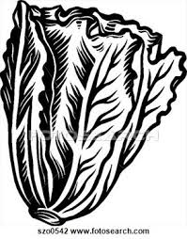](http://www.google.com.eg/url?sa=i&rct=j&q=&esrc=s&source=images&cd=&cad=rja&uact=8&ved=0CAcQjRw&url=http://pixgood.com/head-of-lettuce-clipart-black-and-white.html&ei=E-CgVL-RPJDgaKWXgcAK&bvm=bv.82001339,d.d2s&psig=AFQjCNG6kFMGV9yJyzARDyPKblN1EsaxlA&ust=1419915585840176)

**Teapot1**[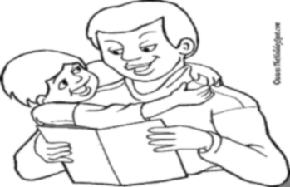](https://www.google.com.eg/url?sa=i&rct=j&q=&esrc=s&source=images&cd=&cad=rja&uact=8&ved=0ahUKEwin1rCt5dTQAhXEnRoKHR2KC_QQjRwIBw&url=http://www.theholidayspot.com/fathersday/more_pictures_to_color.htm&bvm=bv.139782543,d.d2s&psig=AFQjCNHtJDOWwFVVHv4pDibFRAgORrR3rg&ust=1480743402875405)[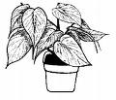](http://images.google.com/imgres?imgurl=http://www.umext.maine.edu/piscataquis/gardening/2003/vol1iss11/housep2.gif&imgrefurl=http://www.umext.maine.edu/piscataquis/gardening/2003/vol1iss11/houseplant.htm&usg=__lXjsQINuEj0_YIjojw6a9VEX4Jk=&h=300&w=351&sz=7&hl=en&start=13&itbs=1&tbnid=zXH2cD1SxY3C3M:&tbnh=103&tbnw=120&prev=/images?q=plant&hl=en&sa=G&imgtype=lineart&as_st=y&tbs=isch:1)

**2- أكتبي الحرف الناقص :**

[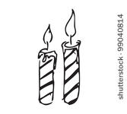](https://www.google.com.eg/url?sa=i&rct=j&q=&esrc=s&source=images&cd=&cad=rja&uact=8&ved=0ahUKEwjg7PvogdXQAhXMfxoKHUtlD_EQjRwIBw&url=http://vector.me/browse/213026/cartoon_candles_vector&psig=AFQjCNEyqcQ_M2nIMGRzQLzJ4yyr-gx7ww&ust=1480751047760209)[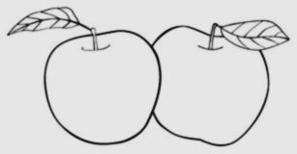](https://www.google.com.eg/url?sa=i&rct=j&q=&esrc=s&source=images&cd=&cad=rja&uact=8&ved=0ahUKEwju3Oj77tTQAhXLtBoKHRyQCqcQjRwIBw&url=https://www.dreamstime.com/stock-illustration-delightful-garden-set-apples-leaves-white-background-collection-image52687550&bvm=bv.139782543,d.d2s&psig=AFQjCNE1UKpL1tbD_aXU0aDfH0Z_zMwtag&ust=1480746007904639)[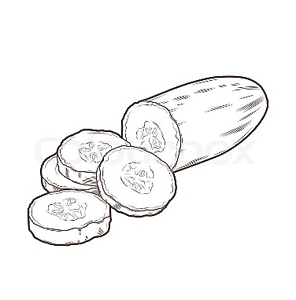](https://www.google.com.eg/url?sa=i&rct=j&q=&esrc=s&source=images&cd=&cad=rja&uact=8&ved=0ahUKEwjI5dLv7dTQAhWDvRoKHTTMAvYQjRwIBw&url=https://www.colourbox.com/vector/sliced-cucumber-isolated-on-a-white-background-line-art-retro-design-vector-illustration-vector-10992052&bvm=bv.139782543,d.d2s&psig=AFQjCNGRC38i3nfXXgLwVeUCq-BFmYJI9A&ust=1480745624614839)

**تفا ..... مــ.....ــلث .....ـــموع خيـــ ..... ر**

**3– إختارى الكلمة المناسبة الداله على الصورة:**

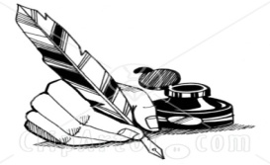

**( خبز - حبر - خير )**

[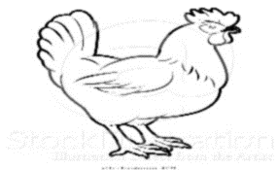](https://www.google.com.eg/url?sa=i&rct=j&q=&esrc=s&source=images&cd=&cad=rja&uact=8&ved=0ahUKEwjAy-janOnQAhVHxxQKHXPVBpwQjRwIBw&url=http://atstockillustration.com/design/vector-illustration-of-a-black-and-white-chicken-in-profile-by-atstockillustration-5188&bvm=bv.141320020,d.ZGg&psig=AFQjCNGiEBJ_NZRdqy2kwsJVFOWHgV5eZA&ust=1481445464962137)

**( ذجاجة – زجاجة – دجاجة )**

[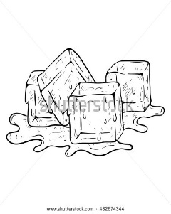](https://www.google.com.eg/url?sa=i&rct=j&q=&esrc=s&source=images&cd=&cad=rja&uact=8&ved=0ahUKEwjJ4Zq9l4_QAhWBvBoKHYtYCQ8QjRwIBw&url=http://www.shutterstock.com/s/melting%2Bice%2Bcube/search-vectors.html&bvm=bv.137901846,d.d24&psig=AFQjCNEznpvJFNseYKf6eb7WuHRELTI0zw&ust=1478351673733240)

**( ثلج – بلح – تلج )**

[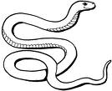](http://images.google.com/imgres?imgurl=http://www.animalcorner.co.uk/britishwildlife/graphics/snakecol.jpg&imgrefurl=http://www.animalcorner.co.uk/britishwildlife/britscol.html&usg=__CtR2zaNUiyTx2Dy7zB2pRT76FKo=&h=463&w=567&sz=35&hl=en&start=415&itbs=1&tbnid=okRUNrxy_4G0gM:&tbnh=109&tbnw=134&prev=/images?q=snake&start=400&hl=en&sa=N&imgtype=clipart&imgc=gray&as_st=y&ndsp=20&tbs=isch:1)

**( تعبان – شعبان – ثعبان )**